 **TIJUANA INSTITUTE OF TECHNOLOGY**

**ACADEMIC**

**DEPARTMENT OF SYSTEMS AND COMPUTATION COMPUTER**

**SYSTEMS ENGINEERING**

**SEMESTER**

FEBRUARY- JULY 2022

**SUBJECT**

BDD-1703SC9C Data Mining

**Activity**

Evaluativo Practice 3

**Teacher**

MC JOSE CHRISTIAN ROMERO HERNANDEZ

**Student**

17212327 -Aldarete Delgado Angel Esteban

17210659 - Villegas Carmona Damaris

**Instructions**

Develop the following problem using R and RStudio for knowledge extraction that the problem requires.

Implement the Naive Bayes classification model with the dataset

Social_Network_Ads.csv and using the e1071 library with the naiveBayes() function. Once the classifier is obtained do the corresponding data visualization analysis.

At the end of the development explain in detail what the Naive Bayes classification model consists of.

Naive Bayes classification model and also the detailed explanation corresponding to data visualization.

data visualization.

**Development**

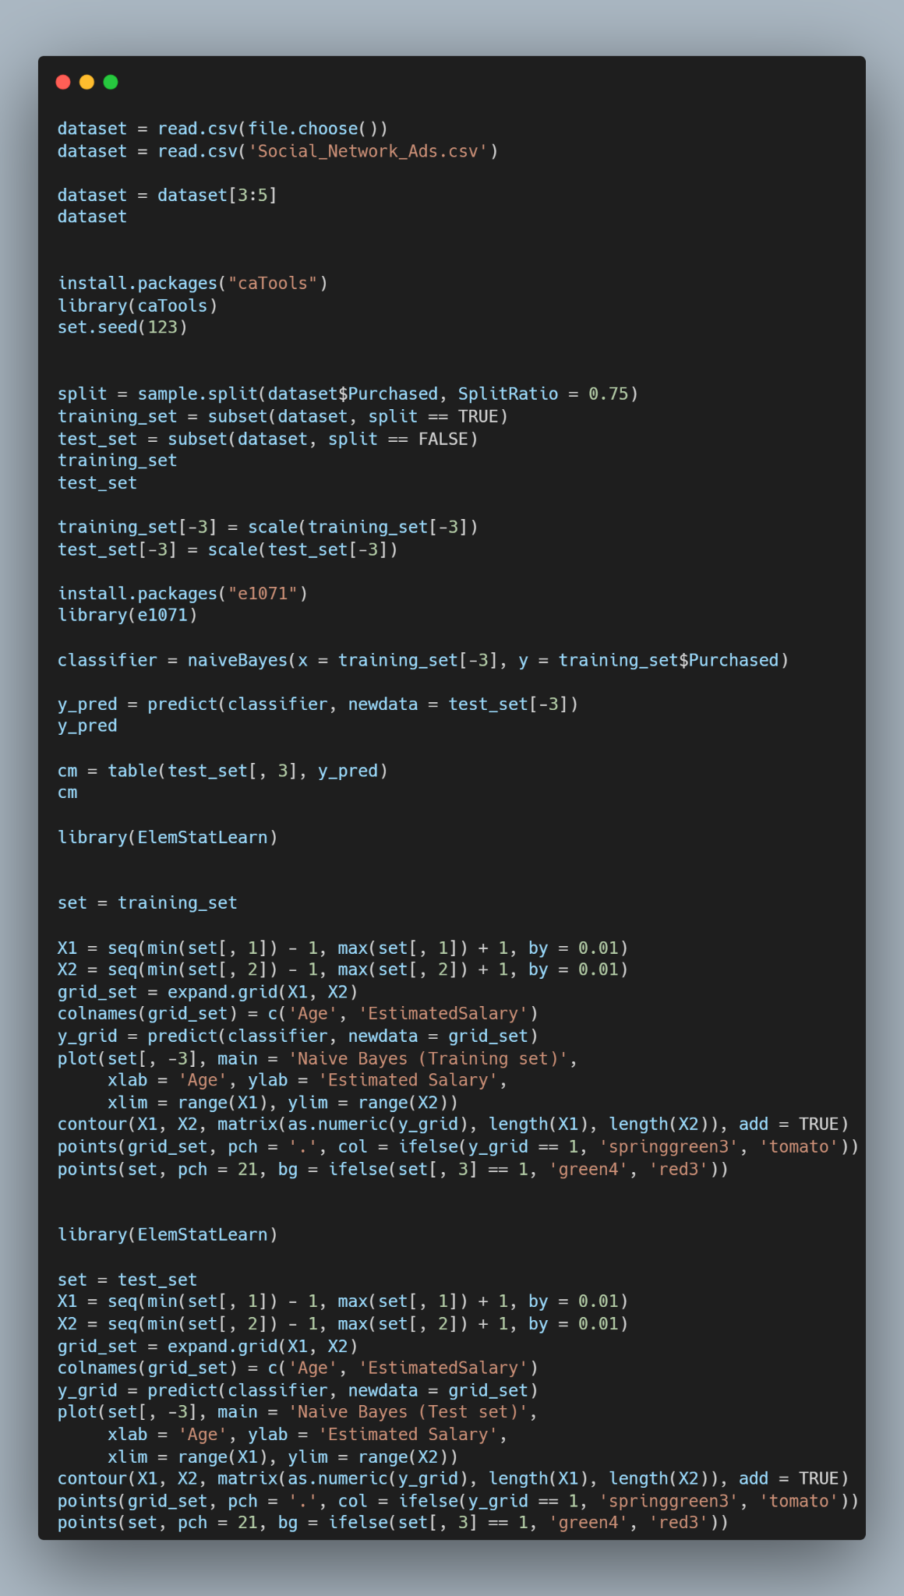

We start by calling the requested csv.



Once this is done with dataser we are going to indicate that we are going to work with only 3 columns out of 5.



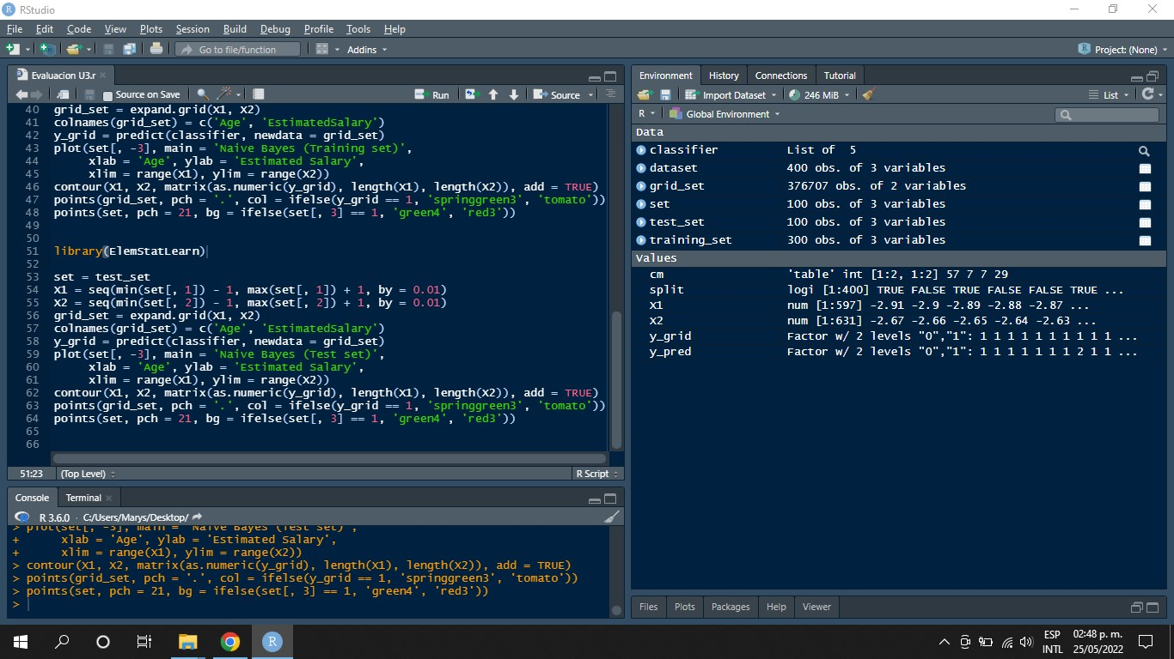

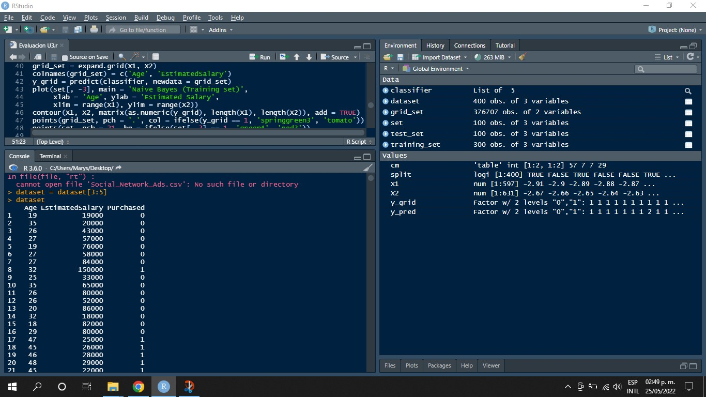

Subsequently, we will take the data that were true and use them for training, and the negative data will be used to test the effectiveness of the model.



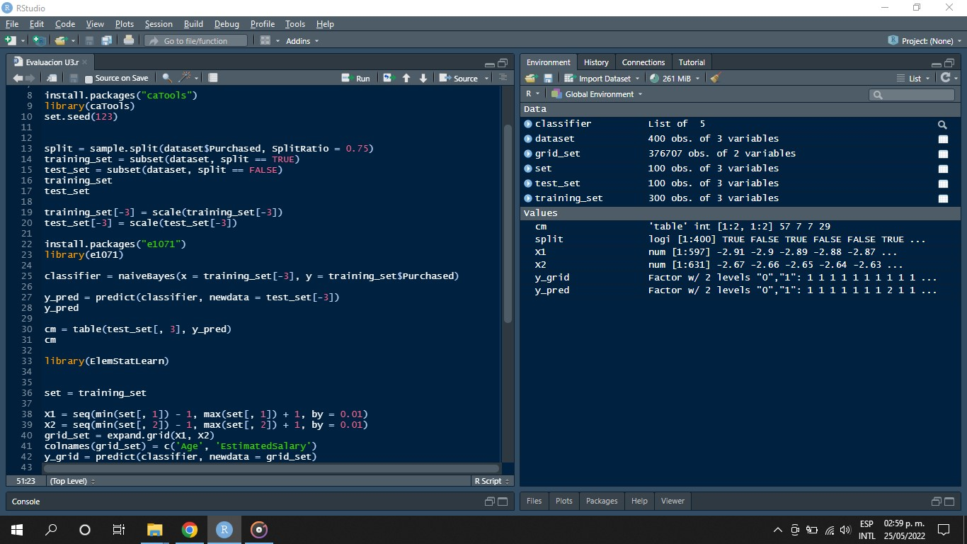

We will install the e1071 library, which helps for statistics.



We are going to take the data set, i.e. we are going to classify it with the Naiven Bayes method.



We will obtain the probability of predicting the correct classifications of the data. We print the prediction.



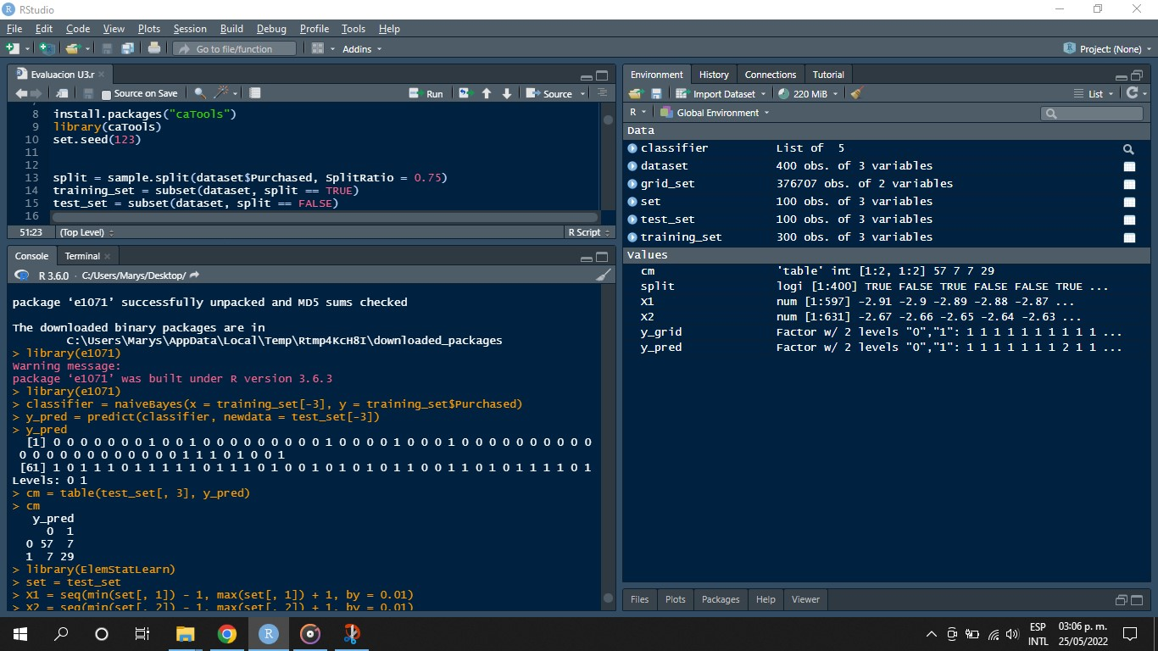

We save the data we obtained in a table and a matrix is created.





We will implement the ElemStatLearn library, which contains statistical functions.



We declare the test data set.



In this section the red background and green background rule is created.



We assign the values to each axis.



The classifier is used to predict each bit of each pixel.



The data is then plotted and a title is assigned to each axis and to the graph.



The value limits are created, as well as the red and green ranges.



Here we review all the prediction data and use "ifelse" to color the dots, keeping in mind that the dots are the actual data, the background is the pixel-by-pixel determination. Considering that the points are the actual data, the background is the pixel-by-pixel determination of the prediction and the points are plotted on the background and the image is created.

determination of the prediction and the points are plotted on the background and the image is created.



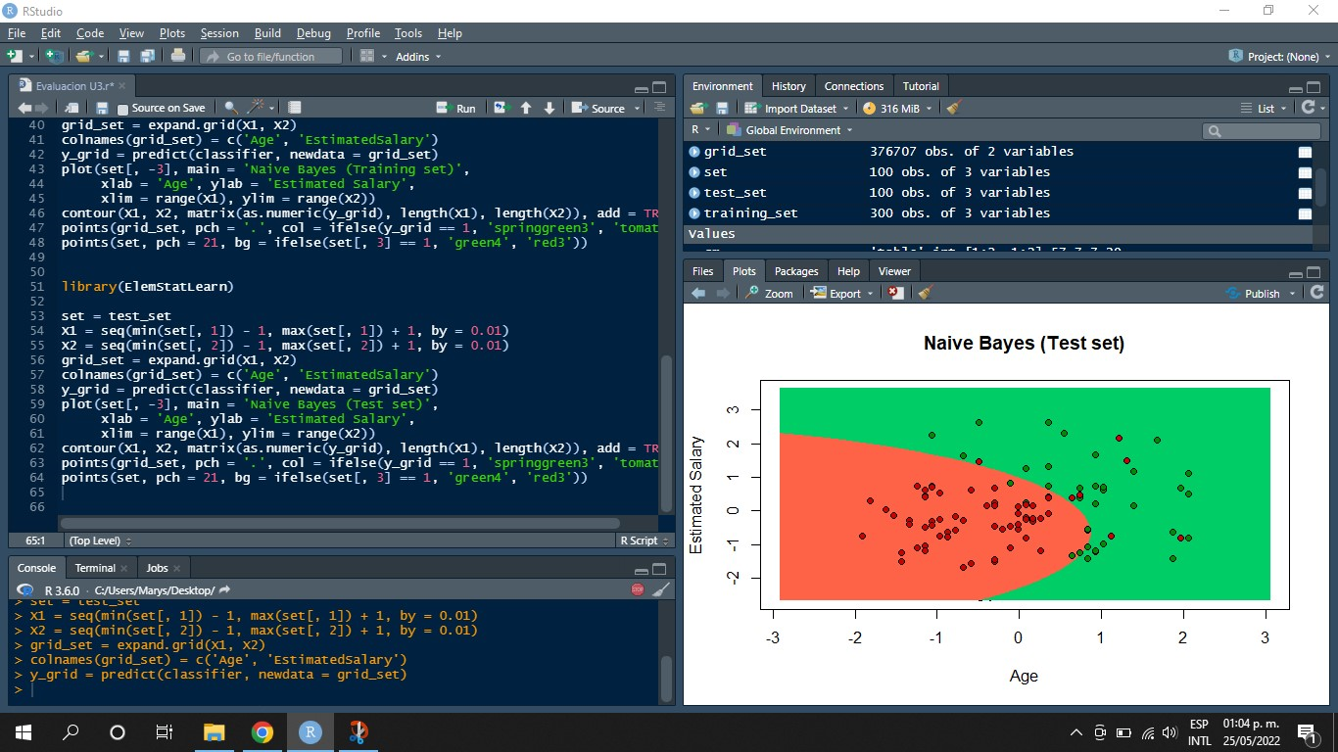

In the same way as in the previous code, the evaluation and classification of the data is performed, only this time, for the graph it will not be the training data but the test data, for which in the "set" command the data of the variable "test_set" obtained in the "set" command assigns the data of the variable "test_set" obtained from the splitting of the division of the corresponding data from the dataset containing the three initial columns of the three initial columns.



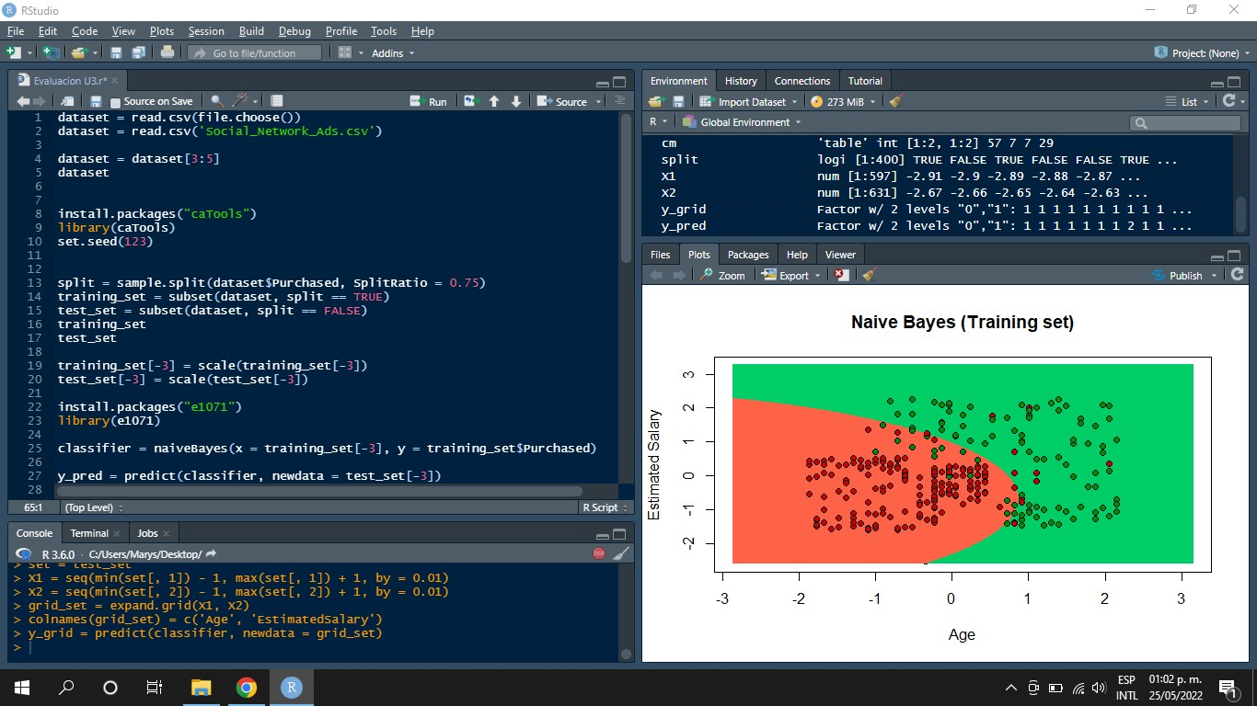

**Conclusion**

With this practice we realize that data analysis are functions or implement databases.

analysis and statistics since they use probabilistic models that determine the probabilities of the data, as well how to take into account that it is important to take into account the bases of probability and statistics in order to understand the data that the models give us and because of that data, In conclusion, this practice itself shows that the models are based on operations of probability and statistics, since these are implemented in the data to be able to have a result on the data and that gives us a panorama that we can understand and be able to determine what decision has to be made

**Naive Bayes models**

In a broad sense, Naive Bayes models are a special class of Machine Learning classification algorithms, or Machine Learning, as we will refer to them from now on. They are based on a statistical classification technique called "Bayes theorem".

They assume that the predictor variables are independent of each other. In other words, the presence of a certain characteristic in a data set is in no way related to the presence of any other characteristic.

They provide an easy way to build models with very good behavior due to their simplicity.

They achieve this by providing a way to calculate the 'posterior' probability of a certain event A occurring, given some probabilities of 'prior' events.

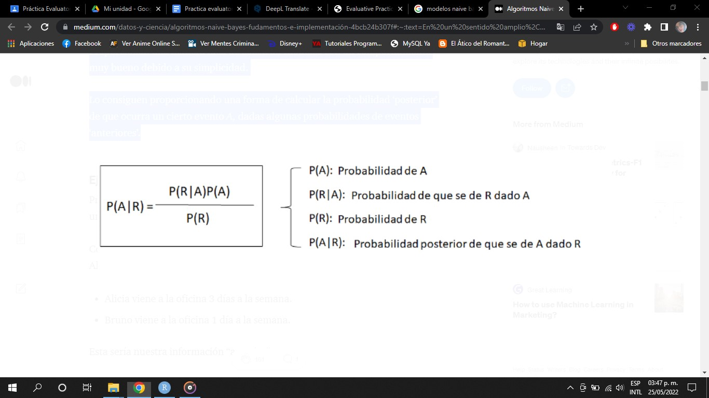

**Disadvantages**

* If the categorical variable has a category in the test data set, which was not observed in the training data set, the model will assign a probability of 0 and will not be able to make a prediction. This is often referred to as zero frequency. To solve this, we can use the smoothing technique.

* Another limitation of Naive Bayes is the assumption of independent predictors. In real life, it is almost impossible for us to obtain a set of predictors that are completely independent.

**Advantages**

* It is easy and fast to predict the class of test data set. It also works well in multiclass prediction.
* When the independence assumption holds, a Naive Bayes classifier performs better compared to other models such as Logistic Regression and less training data is needed.
* It works well in the case of categorical input variables compared to numerical variables.

Bibliography

Gonzalez, L. (2019, September 20). *Naive Bayes – Teoría - Aprende IA*. Aprende IA. Retrieved May 25, 2022, from <https://aprendeia.com/naive-bayes-teoria-machine-learning/>

Roman, V. (2019, April 25). *Algoritmos Naive Bayes: Fundamentos e Implementación | by Victor Roman | Ciencia y Datos*. Medium. Retrieved May 25, 2022, from <https://medium.com/datos-y-ciencia/algoritmos-naive-bayes-fudamentos-e-implementaci%C3%B3n-4bcb24b307f>